Avinash Rampersad Project 2 (unnamed)

The purpose of this template is to assist you in completing a successful project. Please use it, follow and retain the instructions in gray text, and add your work in black where indicated. Keep in mind the evaluation matrix at the end as you do the work and use it to guide what you submit. Use no more than 4 pages of 12-point text excluding figures. You may include as many appendices as you wish for reference. Parts of these may be read as needed.

Your project should involve at least two of: (a) *Planning* (b) *Uncertainty* (c) *Natural language*. You may build a game or a practical application. Building on the work of others is encouraged provided (1) you show that you understand it, and (2) you acknowledge it clearly (e.g., not simply list it among the references).

# Assignment 1 3/13/20

## 1.1 SUMMARY DESCRIPTION

One-paragraph overall description of the purpose, inputs and outputs for your proposed semester project. Do not go into details because the next section does that.

I have been having a tough time trying to figure out a project to do, so I came up with a few ideas and I am hoping that this one meets the necessary requirements of a project. The goal of this project will to have a user submit a text or maybe an audio recording (probably text paragraph) and then have the AI use natural language techniques to break up the paragraph and then determine the mood or feelings of the person. This will take into account uncertainty and then determine what in the paragraph has the person feeling that way. For example, if I write apples make me mad and movies make me happy. The program should be able to determine these relationships.

## 1.2 Requirements

State your requirements for a project. Number the requirements D1, D2, … and N1, N2, … where D means “Definite” and N means “Nice to do.”

i = 1, 2, 3, …

There should be 3-5 items in the “Definite” list and at least 2 in the “Nice to do” list. You will reference these numbered requirements in Phase 2 when you will be asked to show what the project accomplished.

Requirements are *declarative* statements of the application’s intended functionality such as “the expected number of years to graduate college shall appear on the console.” (A statement such as “Find an agent tool” is a procedure step, not a requirement.)

### D1 Input

Input text file should be taken or speech recorded.

### D2 Tokenization

Key subject or topic words should be presented via tokenization and natural language techniques

### D3 Syntax and Semantics determine emotion

Syntax and semantics should be taken on words do separate and display feelings

### D4 Determining Mood and Causation

Uncertainty should be used to display mood(s) and subject(s) of mood(s).

### N1 Mood Improvement

Will give suggestions on how to improve bad moods based on what puts the user in a good mood.

### N2 Probability of Correctness Display

Probability of correctness should be displayed post- each processing.

(More if necessary.)

## 1.3 Design and Theory

Describe the design of your proposed system. The reader should understand how you plan to fit the pieces together. Show this at a high level, as well as providing as much relevant detail as you can. Include at least one (meaningful) annotated figure. An example of a figure form is shown below, in which data flows from one process to the next.

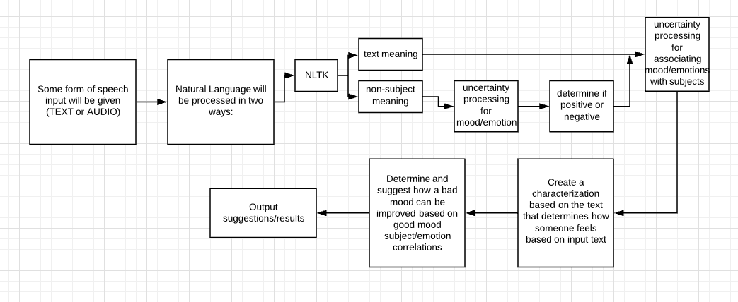

Your response replaces this and the sample figure form.

## 1.4 Tools

Unless you intend to build from scratch (i.e., with a higher-level language), describe the tool(s) you will use.

Python

NLTK Module

Picke

SKLearn (Bayes modeling)

## 1.5 Implementation Fragments

Show enough *parts* of an implementation—or a simplified form of it—to convince the reader that you will have the implementation of the definite requirements completed on time. These can be experimental or exploratory in nature. Cut and paste commented code, and explain its context.

Your response replaces this.

## 1.6 References

Fill in below—and cite each of the following (e.g., “[2]“) within the text. References can include specific places in the notes and textbook.

[1] <https://www.nltk.org/>

[2] <https://github.com/nltk/nltk>

[3] <https://cloud.google.com/natural-language>

…

## 2.8 Evaluation of Phase 1

